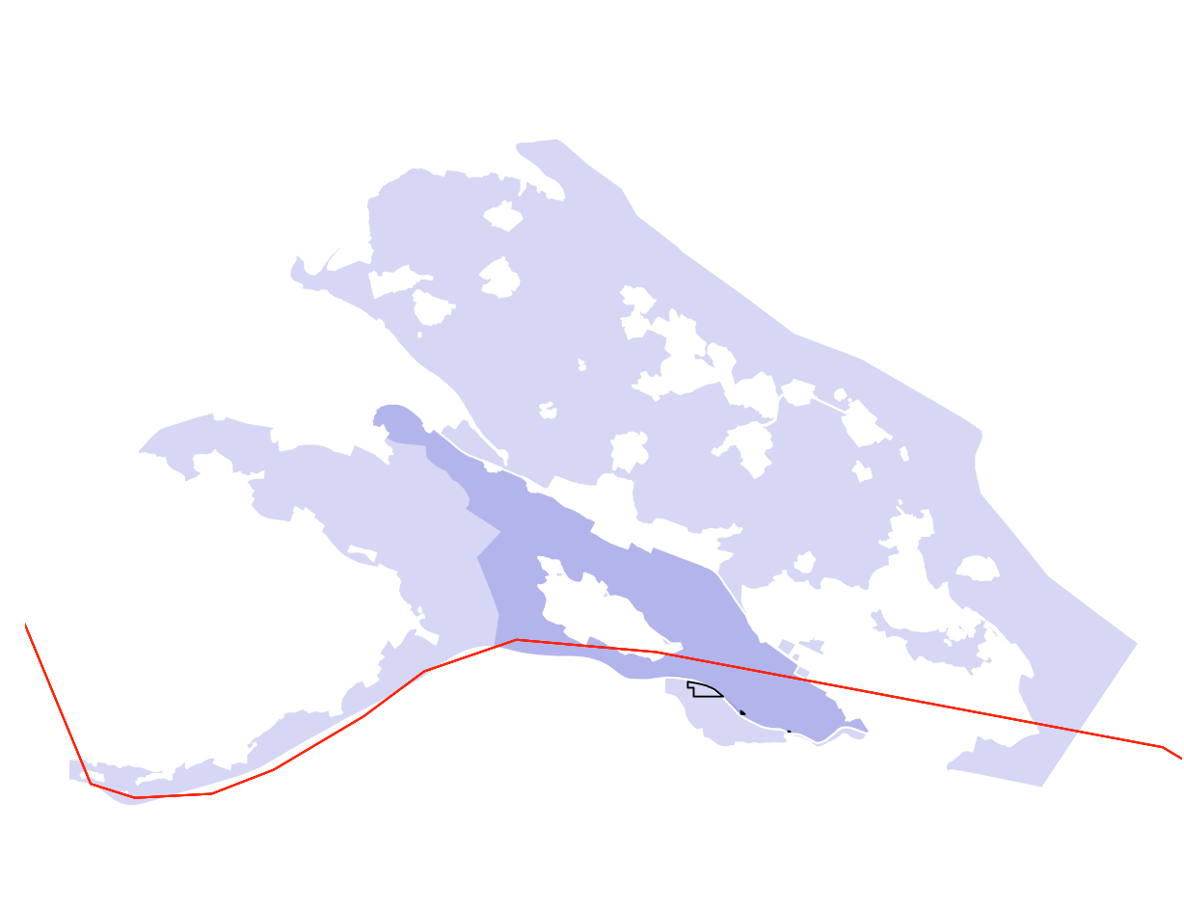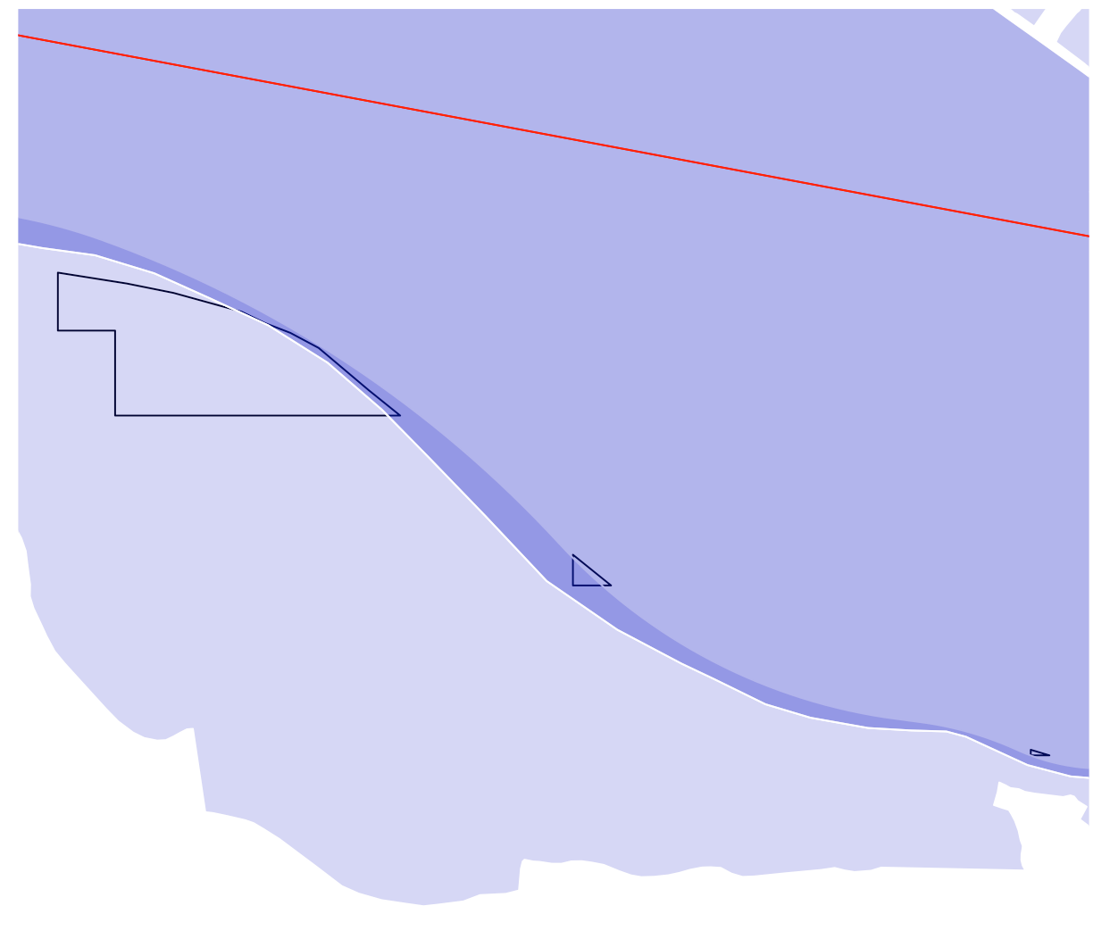

PA = Purple /// GMBA intersec KBA = Black outline /// country border = Red

Takes intersected GMBA/KBA file (so only portion of KBAs that fall within GMBA polygons)

Loops through each GMBA_V2_ID

Finds all PAs that this KBA_GMBA polygon overlaps with

Tracks all the countries that have that mountain range AND the specific country calculated (In this case DEU & CHE)

Calculates the coverage using same method as the original birdlife code

Potential polygon scenarios:

Two Pas within 1 country, KBA/GMBA overlaps one --

KBA/GMBA crosses national border. Does not happen (KBAs are national)

Two Pas within 1 country, KBA/GMBA overlaps both – Needs to be handled. Right now might double count

Two Pas within 1 country, KBA/GMBA overlaps both – Needs to be handled. Right now might double count

Brown – Full KBA calculated as mountainous in original.

Black – GMBA/KBA intersected